Workflow of Prepare Payment Request

Version: 0.3

Date: Dec 2018

|  |  |  |  |
| --- | --- | --- | --- |
| **Amendment History** | | | |
| Change Number | Revision Description | Revision / Version Number | Date |
| 1 | First Draft | V0.1 | 30 Nov 2018 |
| 2 | Add type in claim request master | V0.2 | 3 Dec 2018 |
| 3 | * eClaim change to eAllowance * Claim request change to Payment request * Add details in Validate payment & transfer to HCM | V0.3 | 17 Dec 2018 |
|  |  |  |  |
|  |  |  |  |
|  |  |  |  |
|  |  |  |  |
|  |  |  |  |
|  |  |  |  |

Tables of Contents

1. Introduction 3

2. Validate payment 4

2.1 Create a new Batch 6

2.2 Create a new Sub Batch 8

2.3 Edit Batch 10

3. Transfer to HCM 12

3.1 Submit/Rollback 13

Appendix 1. Attendant template 15

Appendix 2. Validation 16

# Introduction

This function allows payroll officer to create a payment request, then pass by payroll manager to transfer to HCM system. Function have two parts, Validate Payment for payroll preparer enquiry, update or create payment request; Transfer to HCM for payroll manager review submitted payment request, then transfer the request to HCM, also payroll manager allow rollback the record of payment request which is transferred to HCM but still not processed in HCM.

# Validate payment

This function allows payroll officer enquiry payment request record. There are three options of payroll officer: 1. Create a new Batch; 2. Create a sub batch to handle on-hold record of existing request; 3. Edit existing batch record;

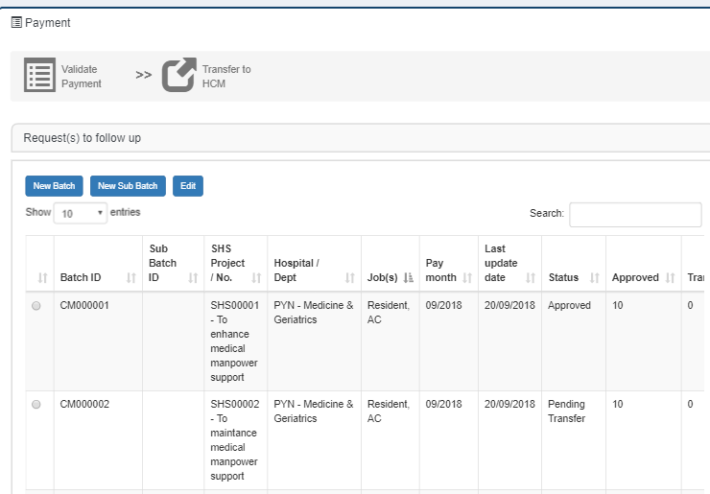

**Screen Item**

|  |  |
| --- | --- |
| Field | Description |
| Radio Button | For payroll officer select record. |
| Batch ID | Index for each record; If record has sub record, will mark to Parent ID (Deck number). |
| Sub Batch ID | Index of sub batch record. |
| Project name/ No. | Project information of batch. |
| Hospital/ Dept | Hospital/ Dept of batch. |
| Job(s) | Jobs of batch. |
| Pay month | Pay month of batch. Format MM/YYYY |
| Last update date | Record last updated date. |
| Status | |  |  | | --- | --- | | Approved | Default status. | | Pending Transfer | Once submit the request, status will update to pending transfer. | | Transferred | If record can transfer to HCM successful, status will update to Transferred. | | Partially Transferred | If record transfer to HCM have any error, or payroll manager rollback transferred record, status will update to partially transferred. | |
| Approved | Default status of batch detail’s record. Sum of approved record. |
| Transferred | Sum of transferred to HCM record. |
| On-Hold | Sum of record which is transfer to HCM have error or rollback by payroll manager. |
| Remark | Error or Rollback, once click the label, system will pop a new dialog to display more details. |

**Screen Button**

|  |  |
| --- | --- |
| Button | Description |
| New Batch | Create a new payment request. |
| New Sub Batch | Create a new sub batch request to handle on-hold record. |
| Edit | System allow user edit payment request which’s status is Approved, other status just allow user to view the details. |

## Create a new Batch

Payroll can create a new batch by click the new Batch button from enquiry page.

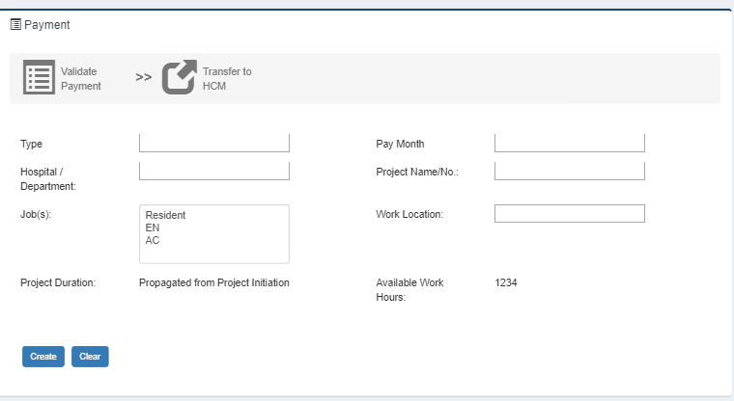

**Screen Item**

|  |  |  |
| --- | --- | --- |
| Field | Description | Type |
| Type | SHS | Textbox |
| Pay month | Default currently month, Date format MM/YYYY | Textbox |
| Hospital/ Department | List of Hospital/ Department which have an active project | Textbox |
| Project Name/ No. | List of Project which is under the selected Hospital/ Department | Textbox |
| Job(s) | List of Job(s) under the selected project. | Multi-select dropdown |
| Work Location |  | Textbox |
| Project Duration | Project Duration information of selected project. | Textbox |
| Available Work Hours | Available work hours of selected project | Label |

**Screen Button**

|  |  |
| --- | --- |
| Button | Description |
| Create | There are three actions after user clicked the button:   1. Create a new request, system will assign the payment id for the request. 2. Auto download the attendance template for payroll officer input the details of request. 3. Redirect to Edit Batch page. |
| Reset | Reset all input value. |

## Create a new Sub Batch

If the record transfer to HCM not success, or payroll manager rollback transferred HCM record, will accumulate the number of on-hold. To settle the on-hold record, payroll officer can create a new sub batch to manage those record, parent request information will pass to new request, payroll officer need fill the pay month only; After created request, payroll officer can new, edit or delete those records, also on-hold count of parent will mark to zero.

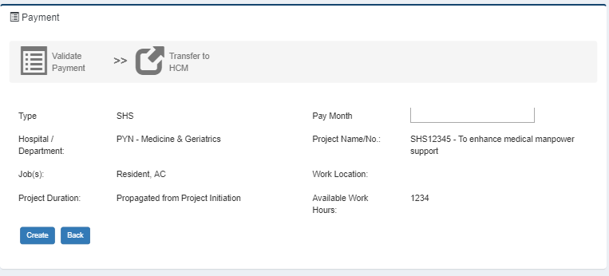

**Screen Item**

|  |  |  |
| --- | --- | --- |
| Field | Description | Type |
| Type | Type of parent request | Label |
| Pay month | Default currently month, Date format MM/YYYY | Textbox |
| Hospital/ Department | Hospital/ Department of parent request | Label |
| Project Name/ No. | Project name/no. of parent request | Label |
| Job(s) | Selected Job(s) of parent request | Label |
| Work Location | Work location of parent request | Label |
| Project Duration | Project Duration of parent request | Label |
| Available Work Hours | Available work hours of parent request project | Label |

**Screen Button**

|  |  |
| --- | --- |
| Button | Description |
| Create | There are three actions after user clicked the button:   1. Create a new request, system will assign the payment id for the request, and the record will show in enquiry form. 2. Auto download the attendance template with on-hold record from parent request for payroll officer modify the details of request. 3. Redirect to Edit Batch page. |
| Reset | Reset all input value. |

## Edit Batch

This function allows payroll officer to edit the details of payment request which the status is Approved, other status allow payroll officer view only.

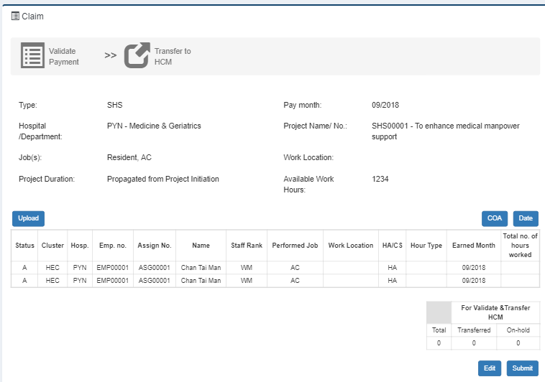







**Screen Item**

|  |  |  |
| --- | --- | --- |
| Field | Description | Type |
| Type | Type of parent request | Label |
| Pay month | Default currently month, Date format MM/YYYY | Label |
| Hospital/ Department | Hospital/ Department of parent request | Label |
| Project Name/ No. | Project name/no. of parent request | Label |
| Job(s) | Selected Job(s) of parent request | Label |
| Work Location | Work location of parent request | Label |
| Project Duration | Project Duration of parent request | Label |
| Available Work Hours | Available work hours of parent request project | Label |

**Screen Button**

|  |  |
| --- | --- |
| Button | Description |
| Upload | After payroll officer ready the attendance template, they can click the upload button to upload record to system, and system will process validation to make sure all record corrects.  If record failed in validation, system will pop a new dialog to show the error message. If record passed the validation, record will auto save as system. |
| COA | Show/hide the details of COA. |
| Date | Show/hide the details of worked hour of each date. |
| Edit | Download the attendance template with existing record, payroll officer can base on the template add, delete or modify record. |
| Submit | Submit the request to payroll manager. Once submitted the request, Upload, Edit and submit button will be disable, payroll officer allow view the request only. |

# Transfer to HCM

This function allows payroll manager to review submitted payment request, once checked no problem then transfer to HCM. Even record transfer to HCM, payroll manager also allows to rollback the record which still not process in HCM.

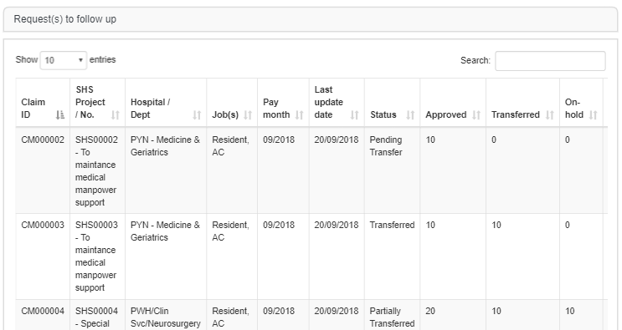

**Screen Item**

|  |  |
| --- | --- |
| Field | Description |
| Payment ID | Payment ID of record |
| Project Name/No. | Project Name/No. of record |
| Hospital/Department | Hospital/Department of record |
| Job(s) | Job(s) of record |
| Pay Month | Pay month of record |
| Status | Status of record |
| Approved | Sum of approved record of the request |
| Transferred | Sum of transferred record of the request |
| On-Hold | Sum of On-Hold record of the request |
| Action | For payroll manager to transfer record to HCM or rollback record from HCM |

## 3.1 Submit/Rollback

After clicking the action button, payroll manager can view the details of payment request. Once click the transfer button, all records of request will transfer to HCM, if there is any error return from HCM, system will pop a new dialog to list the problem, un-success record will accumulate the count of on-hold record, and the status will mark to Partially Transferred. Payroll manager also allow to select record which still not process in HCM to rollback.







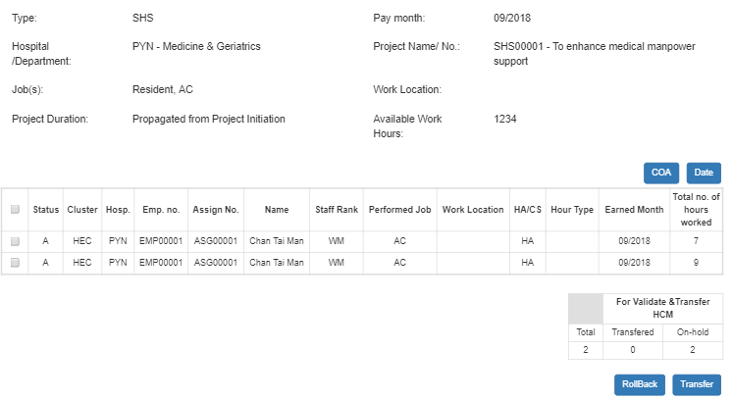

**Screen Item**

|  |  |
| --- | --- |
| Field | Description |
| Type | Type of parent request |
| Pay month | Pay month of request |
| Hospital/ Department | Hospital/ Department of parent request |
| Project Name/ No. | Project name/no. of parent request |
| Job(s) | Selected Job(s) of parent request |
| Work Location | Work location of parent request |
| Project Duration | Project Duration of parent request |
| Available Work Hours | Available work hours of parent request project |

**Screen Button**

|  |  |
| --- | --- |
| Button | Description |
| COA | Show/hide COA details |
| Date | Show/hide worked hour of each date |
| Rollback | Rollback the record from HCM, if checked HCM didn’t process the record, system will delete the record in HCM, then update the record status to on-hold. |
| Transfer | all records of request will transfer to HCM, if there is any error return from HCM, system will pop a new dialog to list the problem, un-success record will accumulate the count of on-hold record, and the status will mark to Partially Transferred |

# Appendix 1. Attendant template

###### Header

|  |  |
| --- | --- |
| Field | Description |
| Project/ No. | Pre-filled claim request information. |
| Project Type | Pre-filled claim request information. |
| Hospital/Department | Pre-filled claim request information. |
| Work Location | Pre-filled claim request information. |
| Pay Month | Pre-filled claim request information. |

###### Details

|  |  |
| --- | --- |
| Field | Description |
| Assignment No. |  |
| Name |  |
| Work Location |  |
| Job |  |
| Hour type | Standard / Non-Standard / Night |
| COA Inst |  |
| COA Fund |  |
| COA Section |  |
| COA Analytic |  |
| COA Type |  |
| Earned Month | Format MM/YYYY |
| Date / No. of hours worked |  |
| Total | Sum of Date / No. of hours worked |

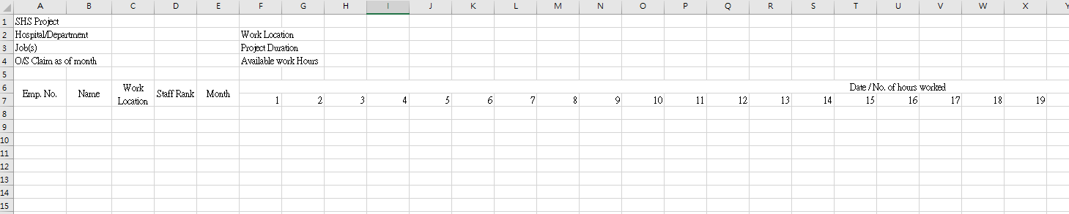

# Appendix 2. Validation

When upload the template, system will do a validation checking, there are three types of the validation result: 1. **Passed**, 2. **Warning**, 3. **Error**.

After upload the file, system will pop a dialog to show the validation result with type equal “**Warning**” or “**Error**”. If the file has any record with “**Error**”, user need fix the problem in the file and then re-upload the file. If the file has record with “**Warning**”, system will pop a confirm dialog to do the double confirm before system accept the upload file record.

Field Validation

|  |  |  |  |
| --- | --- | --- | --- |
| Field | Validation | Type | Error Message |
| Assignment No. | Mandatory | Error | Line #line Assignment number cannot be empty. |
| Name | Mandatory | Error | Line #line Name cannot be empty. |
| Work Location | Mandatory | Error | Line #line Work Location cannot be empty. |
| Hour Type | Mandatory | Error | Line #line Hour Type cannot be empty. |
| Hour Type | Equal “Standard” or “Non-Standard” or “Night” | Error | Line #line Hour Type must equal to “Standard” or “Non-Standard” or “Night”. |
| COA Inst | If Input, max length is 3 | Error | Line #line COA Inst #value can’t longer than 3. |
| COA Fund | If Input, max length is 2 | Error | Line #line COA Fund #value can’t longer than 2. |
| COA Section | If Input, max length is 7 | Error | Line #line COA Section #value can’t longer than 7. |
| COA Analytic | If Input, max length is 5 | Error | Line #line COA Analytic#value can’t longer than 5. |
| COA Type | If Input, max length is 2 | Error | Line #line COA Type #value can’t longer than 2. |
| Earned Month | Mandatory | Error | Line #line Earned Month cannot be empty. |
| Earned Month | Within 1 to 12 | Error | Line #line Earned Month #value must within 1 to 12. |
| Date/ No. of Hours Worked | Allow 1 decimal place | Error | Line #line Date/ No. of Hours Worked #value only allow 1 decimal place. |
| Date/ No. of Hours Worked | Smaller than 24 | Error | Line #line Date/ No. of Hours Worked #value must smaller than 24. |

Cross-fields Validation

|  |  |  |  |
| --- | --- | --- | --- |
| Field | Validation | Type | Error Message |
| Date / No. of hours worked | At least fill one date | Error | Line #line as least fill one date. |
| Assignment No. & Work Location & Job  & Hour Type  & Earned Month | Not allow duplicate **Assignment** No, Work Location, Job, Hour Type and Earned Month | Error | Duplicate record in #line. |

Database Validation

|  |  |  |  |
| --- | --- | --- | --- |
| Field | Validation | Type | Error Message |
| Name | Not match with name which is retrieved from database by the Assignment No | Warning | Line #line name #recordName not match with database name #databaseName |